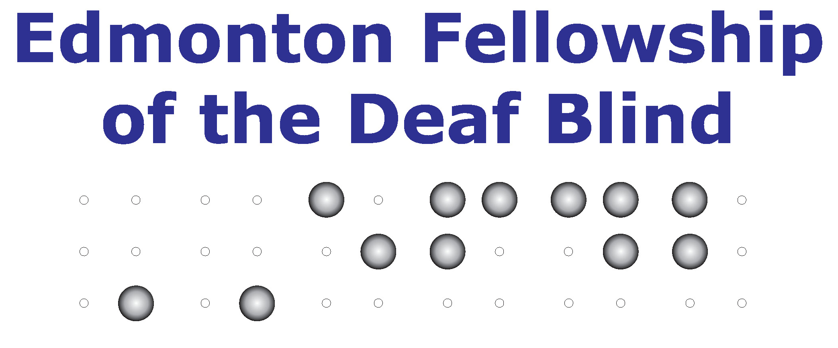
Professional Development by Edmonton Fellowship of the Deaf Blind

This seminar is ideal for Interpreters and Intervenors. This is open to the public and non-staff are welcome to attend this event. The cost of the seminar, for non-staff of EFDB is by donation to EFDB. For the current Staff & Volunteer with EFDB is free admission.

Date & Time: Tuesday, June 11, 2013 (6 to 9 pm)
Location: Sunroom at Alberta School for the Deaf

This is big opportunity and I advise you to not miss this one. We will have Christine “Coco” Roschaert to teach about Deaf-Blind Cultures and training in a variety of Communication Methods for Deaf-Blind. Please rsvp your attendance to Intervenor Coordinator, Dawn Fjell at 780.425.1590 or efdbivcoordinator@gmail.com by Monday, June 10, 2013.

Christine “Coco” Roschaert Biography

Born in Canada, Christine “Coco” Roschaert is Deaf and has Usher Syndrome. She graduated from Gallaudet University in 2006 with a Bachelor's Degree in Communication Studies and now works as an international advocate for Deaf blind rights, and is also a motivational speaker about Deaf blind issues and her personal life stories and has done over 200 presentations around the world. Coco worked in Nigeria, West Africa for two years after Gallaudet (2007-2009), and has lived in Kathmandu, Nepal for three years (2010-2013), where she founded the Nepal Deaf blind Project. Coco is almost fully blind from Usher's and uses a cane everyday as well as tactile sign language. She is fluent in over 17 sign languages and 5 spoken languages. By the end of 2013, Coco will have travelled to 50 countries worldwide, mostly on her own which is an incredible feat for someone who is almost fully blind and Deaf. Her hobbies include hiking, yoga, long-distance walking, writing stories & poetry, vlogging and blogging

